Trifon’s Quest
Our hero Trifon was sent on a quest. You are given his health and the map (as a rectangle matrix) where he will travel. Trifon moves one cell at a time and the quests advances with 1 turn (first operate with health points then increase the turns). Print the outcome of the quest if it is successful or not. A quest is successful if Trifon goes thru all cells on the map and has health above 0.
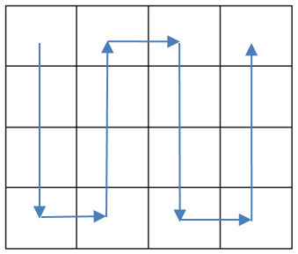
There are different obstacles on his way.
Fight (F) – the hero loses {current number of turns} / 2 of his health points
Heal (H) – the hero restores {current number of turns} / 3 of his health points
Trap (T) – the hero must wait 2 turns (the quest will finish 2 turns later)
Empty cell (E) – nothing happens here just game advances with 1 turn.
* NOTE: The division of the turns must be integer division. For example: 5 / 2 = 2.
The hero always starts his journey in the top left corner (the cell with coordinates [0,0]). And moves as it’s shown on the picture.
Input / Constrains
On the first line you will receive the staring health points. Integer numbers in range [0… 231]
On the second line – dimensions of the map in format: “{Rows} {Cols}”
On the next {Rows} lines -> the map for the journey. Map will contain only the symbols: F, H, T, E
Output
In case the player successfully finishes the game print:
Quest completed!
Health: {Hero’s current health}
Turns: {Total number of turns for the quest}
In case the player did not succeed in completing the quest print:
Died at: [{row}, {col}]
Where row and col are the coordinates of the cell where the health of the hero becomes ≤ 0.
Examples
Input | Output |  | Input | Output |  | Input | Output
10  4 4  FFFF  HHHH  EEEE  EEEE | Quest completed!  Health: 5  Turns: 16 |  | 8  4 3  HHF  FHH  EFT  HHT | Quest completed!  Health: 11  Turns: 16 |  | 50  4 5  TTFFF  EHHFF  THTFF  EHTTT | Died at: [1, 4]

